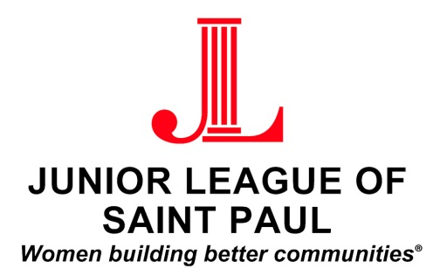

JUNIOR LEAGUE OF SAINT PAUL
COMMUNITY ASSISTANCE FUND
Dear Applicant,

Thank you for your interest in a Community Assistance Grant (CAG) from the Junior League of Saint Paul (JLSP). This fund enables JLSP to immediately address community needs that have significant community impact. This allows flexibility in appropriating funds to community agencies and organizations whose projects and activities are consistent with the JLSP mission and focus.

Your grant request will be appraised based on the specific criteria listed below. Please keep these guidelines in mind as you develop your request and complete the enclosed application.

Criteria:

- Agencies applying for CAG must be a 501(c) (3) organization or the equivalent with the IRS.

- The awarding of grants will be limited to one per organization or agency every 12 months.

- Projects must address JLSP’s current impact area of Food Insecurity.

- Priority will be given to requests that have the ability to impact the most people, address a critical need or have a lasting community impact.

- A CAG will not be considered if:
- The proposal is for a political campaign or purpose;
- It is for a sectarian religious project, although faith-based projects which benefit the general public may be considered;
- Funds are used for general operating expenses or travel;
- It solely benefits an individual person.

- CAG proposals recommended by the Community Council are subject to Board approval.

- Funds must be used within the geographic area of JLSP (Saint Paul and surrounding communities.) Preference will be given to projects serving Saint Paul’s East Side.

- Documentation of the use of the grant must be received by the JLSP within 120 days of disbursement of Community Assistance Funds.

A member of the Community Council will be in touch with you to request a visit to your location and to ask further questions as needed. Please feel free to contact Community Manager Megan Hanson at Community@JLSP.org concerning your application.

JUNIOR LEAGUE OF SAINT PAUL
COMMUNITY ASSISTANCE FUND

Organization:
Contact Person:
Address:

Phone:
Email:
Website:

Date of Application:

- Please describe your organization and whom it impacts in the Saint Paul Community.

- Briefly describe your project. How many people will be served by this project and over what period of time?

- What will the funds be used for? Please be specific.

- Please explain how these funds will specifically impact the issue of food insecurity in the Saint Paul community.

- What is your reason for requesting this funding? Please explain if this is an emergency situation, such as funding from another source is no longer available, or any other information you can give.

- What qualitative and/or quantitative data is there to support the need for this project in our community?

- What will be your measure of success for the project?

- List any Junior League members, if any, who are on your staff, Board of Directors, or who are currently involved in the development of this project:

- Please list the involvement, if any, the Junior League has had with your organization over the past seven (7) years:

- Is the agency requesting funding considered a 501(c) (3) organization?
_____Yes _____No

- Tax ID/ 501C:______________________________________

- Please list the amount of funding (up to $1000) that you are requesting: $______

- Total cost of providing goods or services: $__________________

- List other organizations (including Federal or state monies, etc.) from which you have requested funding for the current fiscal year. List the grantor, the amount requested, and the date you expect to be notified regarding approval thereof. If funding has already been approved, please so note:

- Will a grant from the Junior League enable your organization to receive matching funds?
___Yes ___No

- Is there another resource that can assume financial responsibility for this project upon completion of the Junior League of Saint Paul commitment?

- Please provide the best time of day to reach you and best way that you can be contacted.

- If your organization is selected as a grant recipient, will a representative be available to accept the financial award at a Junior League of Saint Paul Membership Meeting on November 14th, 2017 at 6:00pm? (Attendance will not affect decision as to whether or not your organization will receive funds.)

___Yes, a representative will be present

___No, a representative is not available

Please email your completed application and 501(c) 3 determination letter to: office@jlsp.org by October 1st, 2017.

